Name: Astha Arpit Bhatt

Enroll: 196140316006

**Practical 16**

Develop a simple JSP program for user registration and then control will be transfer it into second page.

**File name: index.html**

<html>

<body>

<form action="hello.jsp" method="post">

Name: <input type="text" name="name" /><br>

Password: <input type="password" name="p" /><br>

<input type="submit">

</form>

</body>

</html>

**File name: hello.jsp**

<%--

Document : hello

Created on : Feb 9, 2022, 4:51:47 PM

Author : hp

--%>

<%@page contentType="text/html" pageEncoding="UTF-8"%>

<!DOCTYPE html>

<html>

<head>

<meta http-equiv="Content-Type" content="text/html; charset=UTF-8">

<title>JSP Page</title>

</head>

<body bgcolor="grey">

<%

String s1 = request.getParameter("name");

String s2 = request.getParameter("p");

out.println("Name: " +s1);

out.println("Password: " +s2);

%>

</body>

</html>

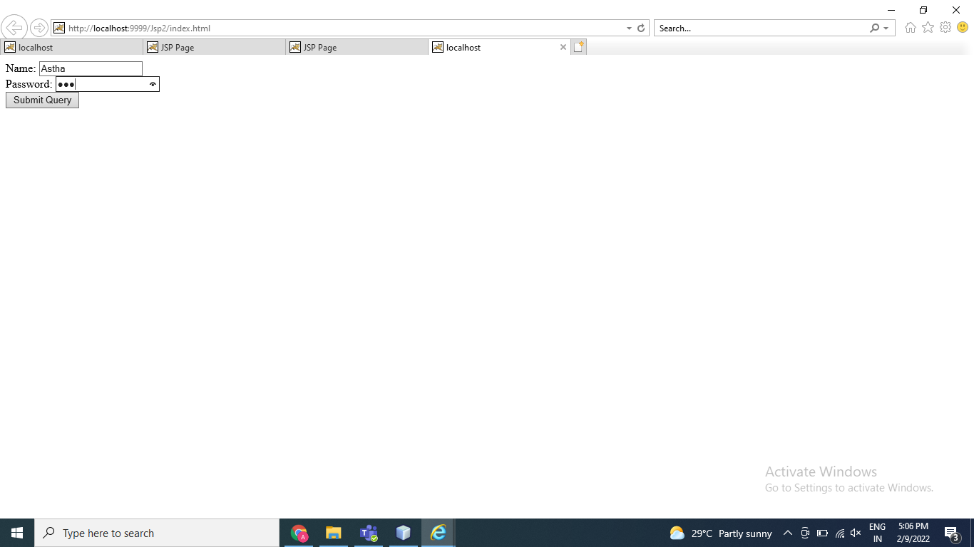

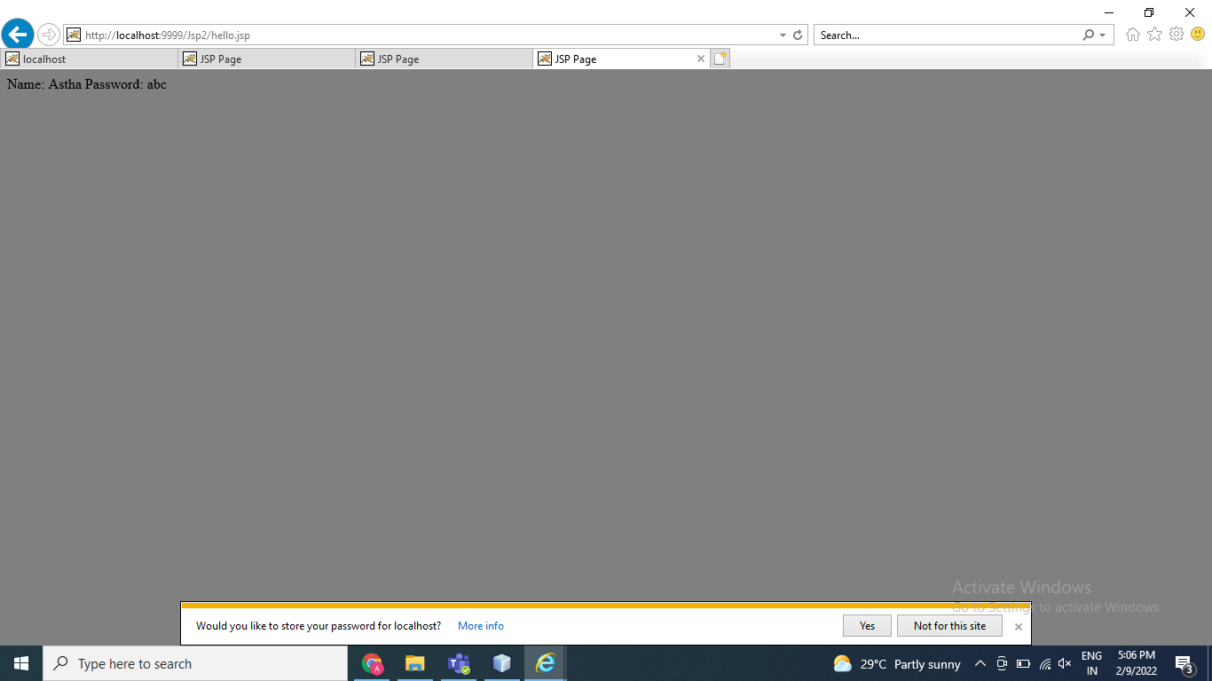

Thanks mam!!

Top of Form

Bottom of Form